建议遇到此问题的用户尝试按照如下步骤处理：

1.    请先更换其他SD支持的浏览器（如：最新版的Chrome、Firefox、Edge浏览器，可以都试试），清除缓存和所有Cookie之后（或者使用无痕模式，一般在浏览器右上方有三个小点，点击之后可以看到无痕浏览），直接复制粘贴打开： <https://www.sciencedirect.com/> ，请不要通过贵学校图书馆跳转。

* [如何清除浏览器的缓存和所有Cookie？](https://cn.service.elsevier.com/app/answers/detail/a_id/26767/supporthub/sciencedirect/kw/browser/track/APOZZAp2Dv8a?WVKGq4a?yCgZ8k6ES75Mv8b?zj?PP?S/track/APMCIAoPDv8Y?UmrGhoa?yKeX1M6Ey75Mv87?zj?PP?y/track/APMKIApbDv8Y?W2rGjUa?yKeKT0qHy75Mv9t?zj?PP_k/track/BvOr2Qo7Dv8Y?evwGkoa?yCeTbk6Xi75Mv8K?zj?PP?D/track/BvMN1wqoDv8Y?YHsGuoa?yKcOEc6iS75Mv8f?zj?PP?W/track/BvM21QqyDv8Y?YzoGpga?yCe7aU6xy75Mv_G?zj?PP9P/track/BvM11QqTDv8Y?SLkGswa?yCe0aU6ES75Mv8p?zj?PP?g/track/BvNdywoKDv8Y?anQGmwa?yCeMKE6pS75Mv9Q?zj?PP_Z/track/BvOFsQrbDv8Y?bWOGl8a?yCeups6Qy75Mv?M?zj?PP8F/track/BvOMrQrsDv8Y?Q2EGqQa?yCgfZs6WS75Mv?h?zj?PP8o/track/BvPtowo_Dv8Y?SVqGpUa?yCeMJc6ty75Mv_j?zj?PP9q/track/BvMpnQoJDv8Y?WxaGgca?yCee5c6lC75Mv9U?zj?PP_d/track/BvOTlQrJDv8Y?bdKGvUa?yCeP5U64y75Mv?_?zj?PP83/track/BvNEkwqEDv8Y?VJGGqEa?yCeZ5U6PS75Mv_w?zj?PP95/track/BvPckwpEDv8Y?e1EGlEa?yCcQZU6TC75Mv9I?zj?PP_B/track/BvNHjwp0Dv8Y?Vc8Gv4a?yCeVJM61C75Mv?q?zj?PP8j/track/BvNbjwodDv8Y?fo6GpQa?yCeXpM6Ny75Mv86?zj?PP?z/track/BvMFiwqgDv8Y?YQyGsUa?yCeGpU65y75Mv?1?zj?PP88/track/BvOogQqhDv8Y?aAaGlsa?yKeXH86eC75Mv?o?zj?PP8h/track/BvPpewr1Dv8Y?RAIGkQa?yCebY863y75Mv_T?zj?PP9a/track/BvNSdQoQDv8e?fL?Gt0a?yCeXo06yS75Mv_6?zj?PP9z/track/BvOOcwqeDv8e?WT5Gooa?yCgJ4069i75Mv9E?zj?PP_N/track/BvMvawoMDv8e?dHlGpsa?yCeRos6NS75Mv8d?zj?PP?U/track/BvNQaQp?Dv8e?fDhGu4a?yCeios69i75Mv91?zj?PP_8/track/BvM7ZwrADv8e?UPZGnka?yCcbdc6Dy75Mv8n?zj?PP?u)

2.    请确认浏览器启用了JavaScript和Cookies，可以参考下方超链接查看对浏览器的要求。

[ScienceDirect联网对浏览器有何要求？](https://cn.service.elsevier.com/app/answers/detail/a_id/26884/supporthub/sciencedirect/kw/browser/track/APOZZAp2Dv8a?WVKGq4a?yCgZ8k6ES75Mv8b?zj?PP?S/track/APMCIAoPDv8Y?UmrGhoa?yKeX1M6Ey75Mv87?zj?PP?y/track/APMKIApbDv8Y?W2rGjUa?yKeKT0qHy75Mv9t?zj?PP_k/track/BvOr2Qo7Dv8Y?evwGkoa?yCeTbk6Xi75Mv8K?zj?PP?D/track/BvMN1wqoDv8Y?YHsGuoa?yKcOEc6iS75Mv8f?zj?PP?W/track/BvM21QqyDv8Y?YzoGpga?yCe7aU6xy75Mv_G?zj?PP9P/track/BvM11QqTDv8Y?SLkGswa?yCe0aU6ES75Mv8p?zj?PP?g/track/BvNdywoKDv8Y?anQGmwa?yCeMKE6pS75Mv9Q?zj?PP_Z/track/BvOFsQrbDv8Y?bWOGl8a?yCeups6Qy75Mv?M?zj?PP8F/track/BvOMrQrsDv8Y?Q2EGqQa?yCgfZs6WS75Mv?h?zj?PP8o/track/BvPtowo_Dv8Y?SVqGpUa?yCeMJc6ty75Mv_j?zj?PP9q/track/BvMpnQoJDv8Y?WxaGgca?yCee5c6lC75Mv9U?zj?PP_d/track/BvOTlQrJDv8Y?bdKGvUa?yCeP5U64y75Mv?_?zj?PP83/track/BvNEkwqEDv8Y?VJGGqEa?yCeZ5U6PS75Mv_w?zj?PP95/track/BvPckwpEDv8Y?e1EGlEa?yCcQZU6TC75Mv9I?zj?PP_B/track/BvNHjwp0Dv8Y?Vc8Gv4a?yCeVJM61C75Mv?q?zj?PP8j/track/BvNbjwodDv8Y?fo6GpQa?yCeXpM6Ny75Mv86?zj?PP?z/track/BvMFiwqgDv8Y?YQyGsUa?yCeGpU65y75Mv?1?zj?PP88/track/BvOogQqhDv8Y?aAaGlsa?yKeXH86eC75Mv?o?zj?PP8h/track/BvPpewr1Dv8Y?RAIGkQa?yCebY863y75Mv_T?zj?PP9a/track/BvNSdQoQDv8e?fL?Gt0a?yCeXo06yS75Mv_6?zj?PP9z/track/BvOOcwqeDv8e?WT5Gooa?yCgJ4069i75Mv9E?zj?PP_N/track/BvMvawoMDv8e?dHlGpsa?yCeRos6NS75Mv8d?zj?PP?U/track/BvNQaQp?Dv8e?fDhGu4a?yCeios69i75Mv91?zj?PP_8/track/BvM7ZwrADv8e?UPZGnka?yCcbdc6Dy75Mv8n?zj?PP?u)

3. 造成“Are you a Robot”检测的一个常见原因是电脑的系统时间设置不对，请参考下方截图，打开电脑的控制面板（Control panel），开启“系统网络时间”。

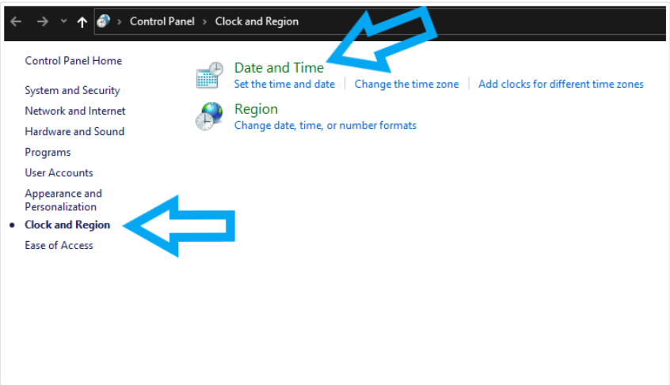

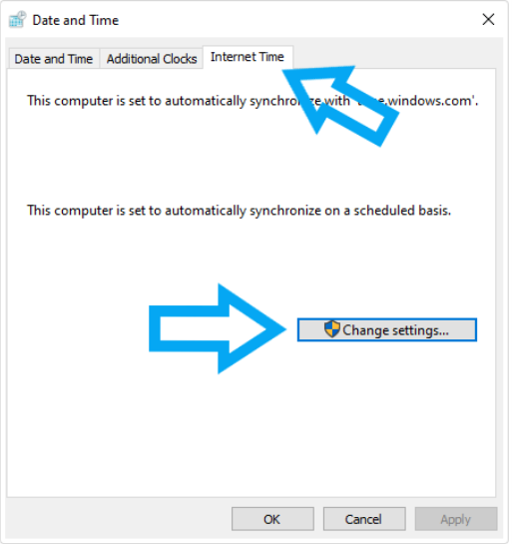



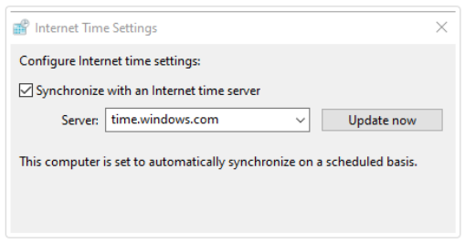

4. 如果完成上述操作之后，直接打开SD依旧存在问题，为了准确定位问题，请提供以下信息：

a. 如果您是从图书馆跳转访问ScienceDirect数据，请提供您从图书馆开始访问ScienceDirect网站看到的错误页面的全屏截图（含网址部分）；如果您是直接打开ScienceDirect数据库，请使用Chrome/Edge浏览器的无痕模式，直接打开[https://www.sciencedirect.com/](https://nam11.safelinks.protection.outlook.com/?url=https%3A%2F%2Fwww.sciencedirect.com%2F&data=05%7C02%7Cx.liu%40elsevier.com%7C99e1ed7b7ade4fa1056008dccb2a4417%7C9274ee3f94254109a27f9fb15c10675d%7C0%7C0%7C638608630837792829%7CUnknown%7CTWFpbGZsb3d8eyJWIjoiMC4wLjAwMDAiLCJQIjoiV2luMzIiLCJBTiI6Ik1haWwiLCJXVCI6Mn0%3D%7C0%7C%7C%7C&sdata=%2FMcBUHl8NwiiDi63jSq5n5JY7DierEPPiEY1kO%2FQ5Yw%3D&reserved=0)的全屏截图（含网址部分）；请将所有截图存到word文档内。

b. HAR文件，获取办法请参考另附文件